|  |  |  |  |  |
| --- | --- | --- | --- | --- |
| **Name:            Lab Section: Id No:** | | | | |
| **Pre-lab Session work (5M)** | **In-Lab Session work (15M)** | **Post Lab session work (5M)** | **Viva**  **(5M)** | **Total Marks**  **30M** |
|  |  |  |  |  |
| **Remarks if any:** | | | | |
| **Date: Signature of the Instructor Marks awarded** | | | | |

**Medical Imaging and Image Processing-Lab**

**Fourier analysis of Images**

**lab3\_Solutions.pdf**

Frequency domain analysis is a very important part in image processing, especially in image enhancement, noise reduction and image filtering. The processing in frequency domain simplifies the design of filters and reduces the computational complexity. Frequency domain representation gives you control over the whole images, where you can enhance (eg edges) and suppress (eg smooth shadow) different characteristics of the image very easily.

**Objectives:**

To

1. find the magnitude and phase spectrum of various images.
2. understand the importance of phase information.
3. recognise the importance of zero padding
4. discover the properties of 2D FFT such as rotation and shifting.

**Basic Theory:**

The two-dimensional discrete Fourier transform (DFT) of an image *f*(*x,y*) of size *M*x*N* is represented by:

C:\Users\mypc\Desktop\Sparse\DIP\DIP_15EC4110\Labs\New folder\Lab5\Frequency Domain Processing_files\DFT.gif

The corresponding inverse of the above discrete Fourier transform is given by the following equation:

C:\Users\mypc\Desktop\Sparse\DIP\DIP_15EC4110\Labs\New folder\Lab5\Frequency Domain Processing_files\InvDFT.gif

The magnitude and phase spectrum of an image *f* (*x, y*) is represented by

**

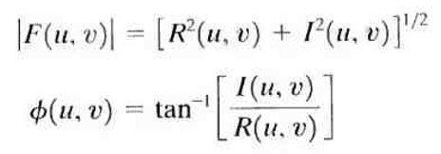

where *R*(*u*, *v*) and *I*(*u*, *v*) are the real and imaginary components of the spectrum *F*(*u*, *v*). Similarly the power spectrum is represented by

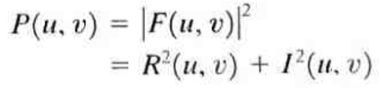

**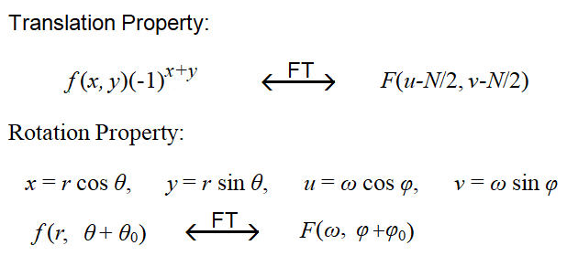**

**Example1:** Generate an image of size 30x30 with zero magnitudes. Then create a rectangular of size 5x20 with unity magnitude. Find the magnitude spectrum and display. Use fftshift to display the spectrum in the center. Use zero padding for fine resolution. For more visibility use log of magnitude spectrum.

**Refer MIP\_Ex\_3\_1.m**

**< Type the Matlab codes here >**

**< Plot the figures and type the results here >**

**Example2:** Find and display of magnitude and phase spectrumof a synthetic image (parameters are given in the Matlab code).Rotate the image by 45O.Now reconstruct the image:

1. Using both magnitude and phase spectrums.
2. Using only magnitude spectrum.
3. Using only phase spectrum.
4. Comment on the results

**Refer MIP\_Ex\_3\_2.m**

**< Type the Matlab codes here >**

**< Plot the figures and type the results here >**

**Example2:** Repeat the above for various images of choice.

**Refer MIP\_Ex\_3\_3.m**

**< Type the Matlab codes here >**

**< Plot the figures and type the results here >**

**Lab3-Exercise Questions**

Exercise1: (a) Write a Matlab code to generate the following images. Assume that the width

of the white pixel for Fig(a) and height of the white pixel Fig(b) are unity.

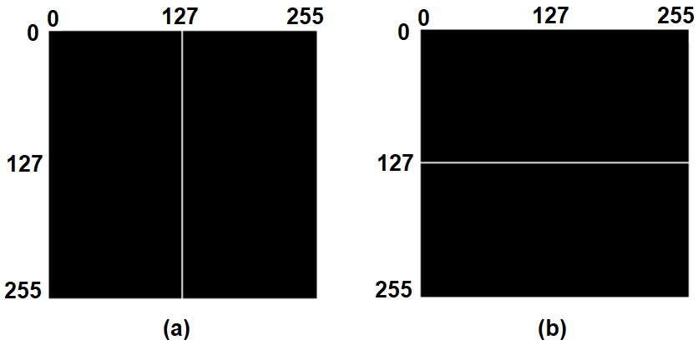

(b) Find and display the magnitude and phase spectrums.

(c) Suppose the vertical line in Fig(a) and horizontal line in Fig(b) are rotated by

(i) ±30O, (ii) ±45O and (iii) ±90O. Find and display the magnitude and phase

spectrums. Comment on the results.

Exercise2: (a) Write a Matlab code to generate the following images. Assume that the radius

of circle is 32 for Fig(a).

(b) Find and display the magnitude and phase spectrums.

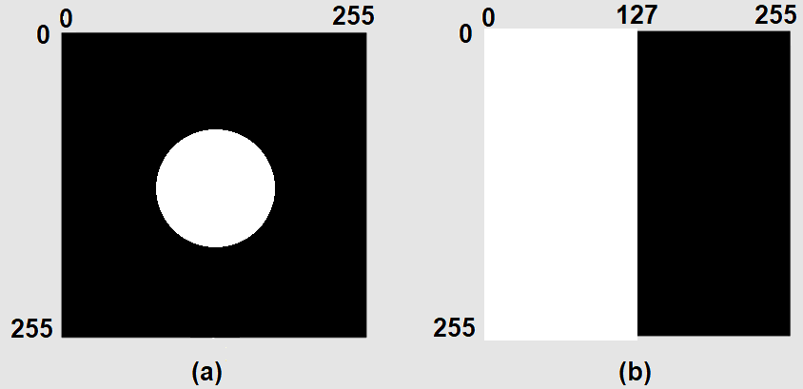

Exercise3: Read an image of your choice.

1. Find and display the magnitude and phase spectrum of image.
2. Now reconstruct the image with
3. Only magnitude spectrum
4. Only phase spectrum
5. Combining the magnitude and phase spectrum.
6. With the above results, discuss the importance of phase information of image.

Exercise4: Read two images of your choice.

1. Find and display the magnitude and phase spectrums of two images.
2. Now swap the phase response of two images, while keeping the magnitude responses are same and reconstruct the two images. Based on the results illustrate the importance of the phase response.

Exercise5: (a) Write a Matlab code to generate the following images.

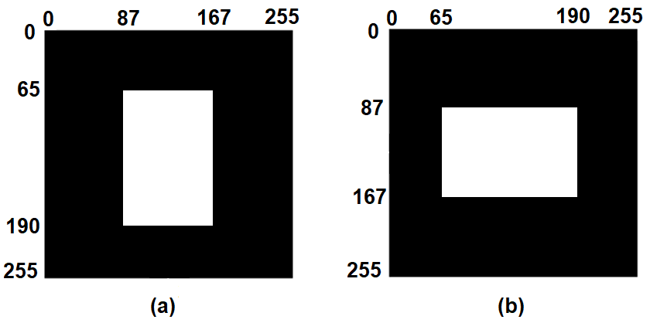

(b) Find and display the magnitude and phase spectrums.

(c) Suppose the white rectangular images are rotated by

(i) ±45O and (ii) ±120O. Find and display the magnitude and phase

spectrums. Comment on the results.

**< Type the Matlab codes here >**

**< Plot the figures and type the results here >**